User Acceptance Testing (UAT) Template
Date | 30 September 2026
Team ID | SWTID-2026-7220
Project Name | Import Data using Transform Maps (Spreadsheet)
Maximum Marks | 10 Marks

Project Overview
Project Name: Employee Data Management using ServiceNow Import Sets, Transform Maps and Coalesce
Project Description: A ServiceNow solution that imports employee data from Excel using Import Sets and Transform Maps, applies Coalesce on Employee ID to prevent duplicate records, and provides reports and dashboards for employee data visibility.
Project Version: 1.0
Testing Period: 30 September 2026

Testing Scope
• Employee spreadsheet import
• Import Set staging
• Transform Map field mapping
• Employee ID Coalesce behavior
• Insert and update behavior
• Repeat-import duplicate prevention / ignore behavior
• Employee reports
• Employee Analytics Dashboard

Testing Environment
URL/Location: ServiceNow developer instance
Credentials: Tester login required; credentials should not be recorded in this document.

Test Cases
Test Case ID | Test Scenario | Test Steps | Expected Result | Actual Result | Pass/Fail
TC-001 | Import employee spreadsheet | Load Employee Import → choose Excel → Sheet 1 → Header 1 → Submit. | Import completes successfully. | To be filled from final screenshot. | Pass/Fail
TC-002 | Transform employee data | Run Sample Spreadsheet Import Transform Map. | Employee data is transferred to Employee Test. | To be filled from final screenshot. | Pass/Fail
TC-003 | Coalesce existing employee | Import an existing Employee ID with changed Name/Email. | Existing Employee Test record is updated, not duplicated. | Verified during project testing. | Pass
TC-004 | Insert new employee | Import a completely new Employee ID. | A new Employee Test record is created. | Verified during project testing. | Pass
TC-005 | Repeat same import | Upload the same Excel file again and transform using the same map. | Expected task result: 0 Inserted, 0 Updated, 4 Ignored. | Verify final Transform History. | Pass/Fail
TC-006 | Department report | Open Employees by Department report. | Department-wise employee data is displayed. | Created successfully. | Pass
TC-007 | Location report | Open Employees by Location report. | Location-wise employee data is displayed. | Created successfully. | Pass
TC-008 | Employee list report | Open Employee List Report. | Employee records are displayed in list form. | Created successfully. | Pass
TC-009 | Dashboard | Open Employee Analytics Dashboards. | Reports/widgets are available on the dashboard. | Dashboard created; widgets to be finalized if needed. | Pass/Fail

Bug Tracking
Bug ID | Bug Description | Steps to Reproduce | Severity | Status | Additional Feedback
BG-001 | No writable dashboards available while adding reports | Open Add to Dashboard from a report when dashboard is not writable. | Medium | Open/Configuration issue | Dashboard permissions/ownership need to be corrected.

Sign-off
Tester Name: ______________________________
Date: 30 September 2026
Signature: _________________________________
Project Manager / Product Owner Sign-off: _________________________________

Screenshots to Attach
1. Employee Import staging table containing the 4 imported rows.
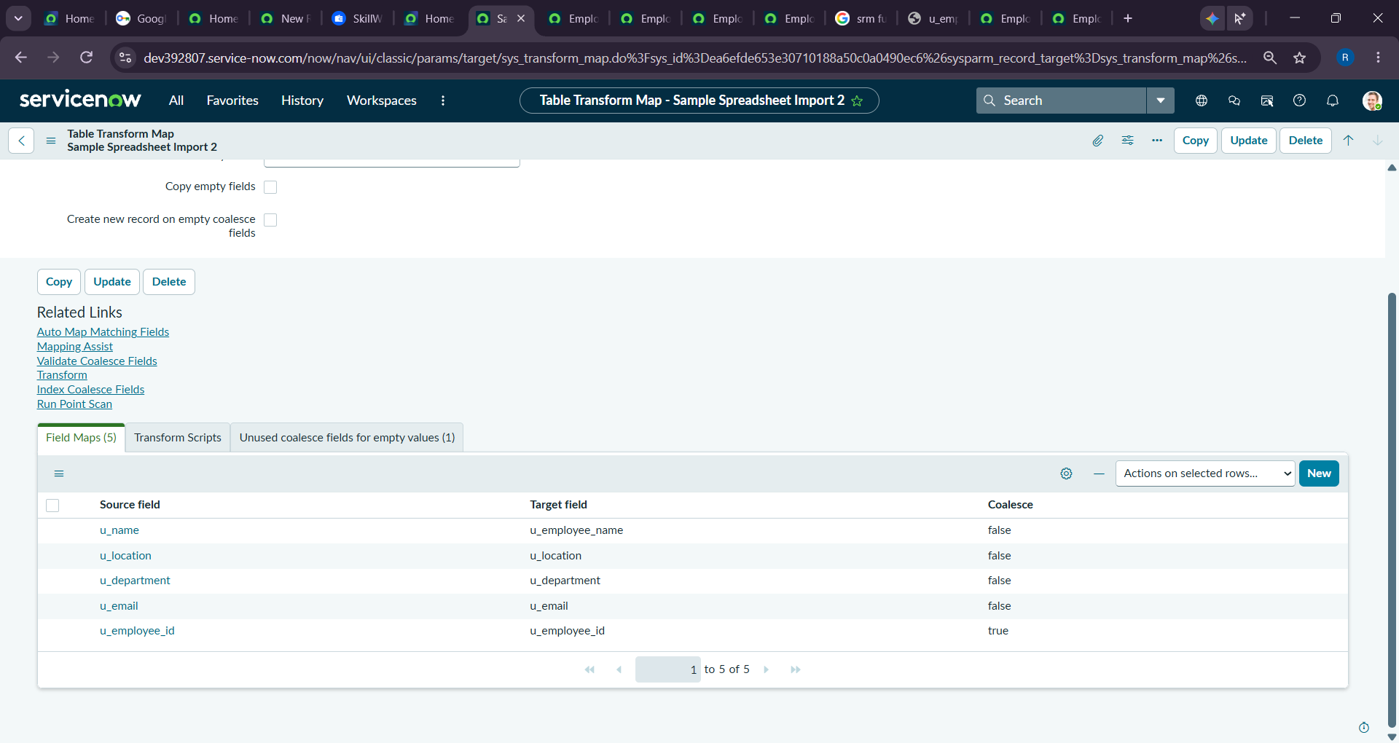
2. Sample Spreadsheet Import Transform Map.
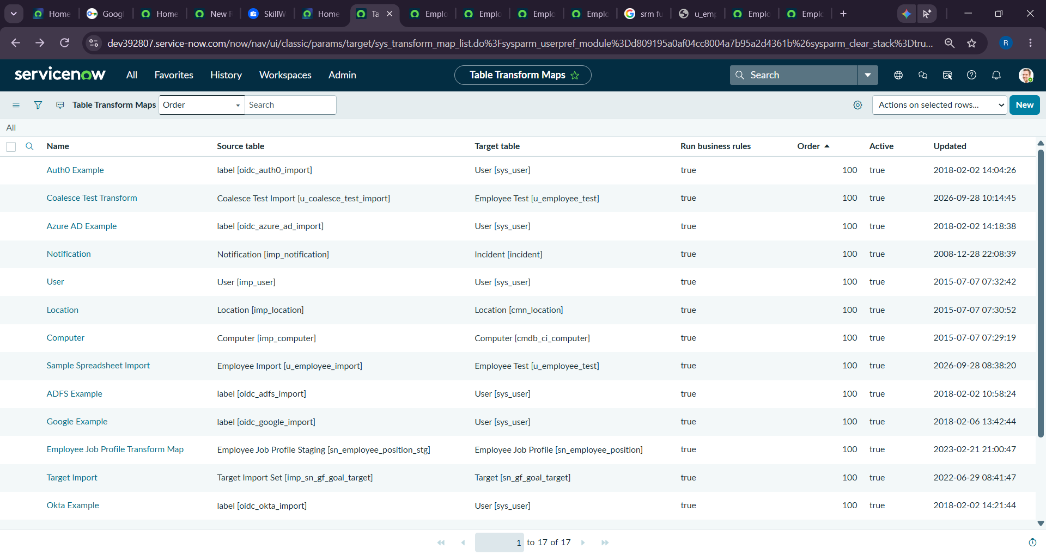
3. Employee ID field map with Coalesce enabled.
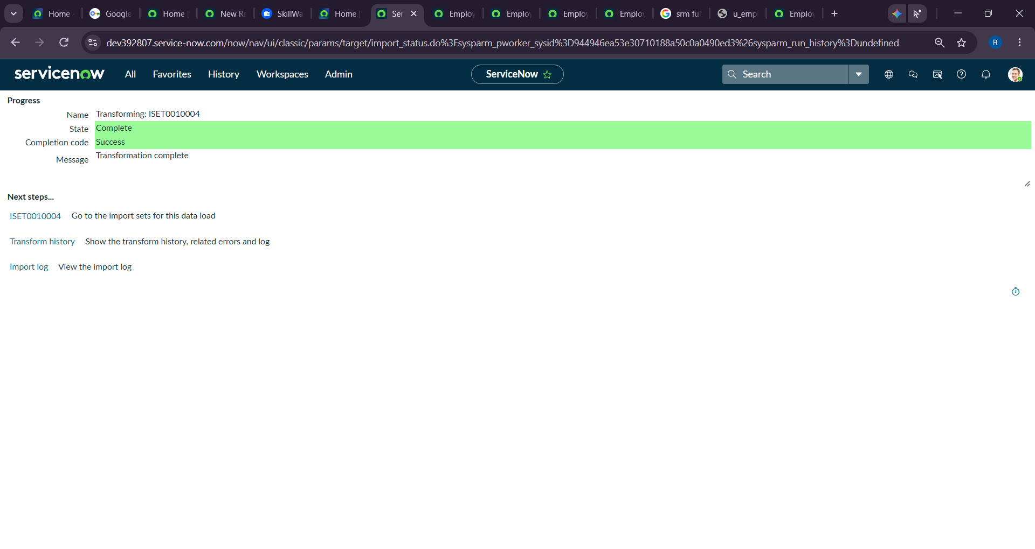
4. Transform History showing the first import results.
5. Employee Test table showing inserted/updated records.
6. Transform History for the repeated import.
7. Employee Analytics Dashboard with the completed reports.
